Lab - 8

Name: Jatvish Yechuri
Roll no : 36

DJANGO setup:

1. Create a python virtual env:

python3 -m venv myenv

2. activate:

source myenv/bin/activate

3. install django inside vm:

pip install django

Q1 Create a website with two pages.First page contains:
RadioButton with HP, Nokia, Samsung, Motorola, Apple as options.
CheckBox with Mobile and Laptop as items. TextBox to enter quantity.
There is a button with text as "Produce Bill".
On Clicking Produce Bill button, item should be displayed with total amount on another
page.

Create a Django Project:

django-admin startproject Lab8_Homework

cd Lab8_Homework // to navigate inside the dir

Create Django Apps:

python manage.py startapp billgenerator
python manage.py startapp feedbackform

Register Apps in settings.py(Lab8_Homework/settings.py):

INSTALLED_APPS = [
'django.contrib.admin',
'django.contrib.auth',
'django.contrib.contenttypes',
'django.contrib.sessions',
'django.contrib.messages',
'django.contrib.staticfiles',
'billgenerator',
'feedbackform',

]

Configure URLs(Lab8_Homework/urls.py):

from django.contrib import admin
from django.urls import path, include

urlpatterns = [
path('admin/', admin.site.urls),
path('register/', include('register.urls')),
path('bookvote/', include('bookvote.urls')),
path('cgpa/', include('cgpa.urls')),
]

billgenerator/views.py:

from django.shortcuts import render

# Dictionary for item prices
PRICES = {
"HP": {"Mobile": 20000, "Laptop": 50000},
"Nokia": {"Mobile": 15000, "Laptop": 40000},
"Samsung": {"Mobile": 25000, "Laptop": 60000},
"Motorola": {"Mobile": 18000, "Laptop": 45000},
"Apple": {"Mobile": 70000, "Laptop": 120000},
}

def bill_page(request):
bill = None

if request.method == "POST":
brand = request.POST.get("brand")
items = request.POST.getlist("items")
quantity = int(request.POST.get("quantity"))

total = sum(PRICES[brand][item] * quantity for item in items)

bill = {
"brand": brand,
"items": items,
"quantity": quantity,
"total": total
}

return render(request, "bill.html", {"bill": bill})

billgenerator/urls.py:

from django.urls import path
from . import views

urlpatterns = [
path('', views.bill_page, name='bill_page'),
]

templates/bill.html:

<!DOCTYPE html>
<html>
<head>
<title>Bill Generator</title>
</head>
<body>
<h2>Bill Generator</h2>

{% if bill %}
<h3>Generated Bill</h3>
<p>Brand: <strong>{{ bill.brand }}</strong></p>
<p>Items: <strong>{{ bill.items|join:", " }}</strong></p>
<p>Quantity: <strong>{{ bill.quantity }}</strong></p>
<p>Total Amount: <strong>₹{{ bill.total }}</strong></p>
<a href="">Generate New Bill</a>
{% else %}
<form method="post">
{% csrf_token %}
<h3>Select Brand:</h3>
<label><input type="radio" name="brand" value="HP" required> HP</label><br>
<label><input type="radio" name="brand" value="Nokia"> Nokia</label><br>
<label><input type="radio" name="brand" value="Samsung"> Samsung</label><br>
<label><input type="radio" name="brand" value="Motorola"> Motorola</label><br>
<label><input type="radio" name="brand" value="Apple"> Apple</label><br>

<h3>Select Items:</h3>
<label><input type="checkbox" name="items" value="Mobile"> Mobile</label><br>
<label><input type="checkbox" name="items" value="Laptop"> Laptop</label><br>

<h3>Enter Quantity:</h3>
<input type="number" name="quantity" required><br>

<button type="submit">Produce Bill</button>
</form>
{% endif %}
</body>
</html>

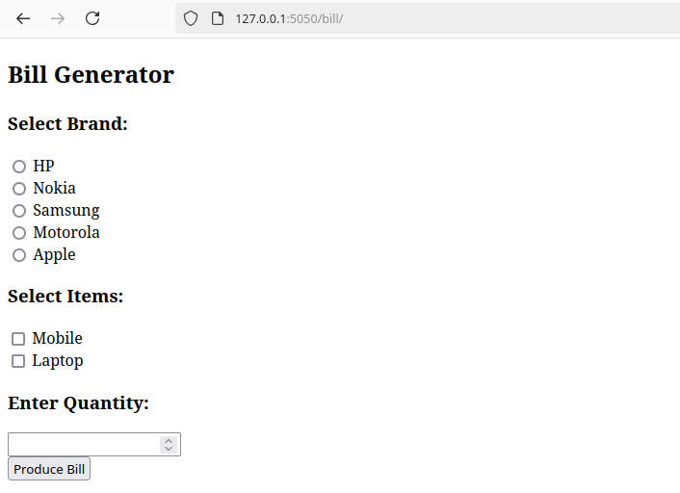
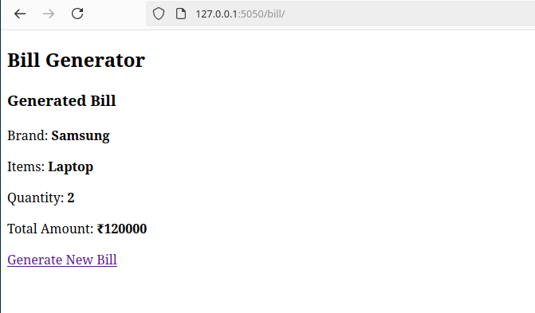

Q2)Write a program to display the following feedback form. The different options for the list
box must be ASP-XML, DotNET, JavaPro and Unix,C,C++. When the Submit Form button is clicked after
entering the data, a message as seen in the last line of the above figure must be displayed

feedbackform/views.py:

from django.shortcuts import render

def feedback_page(request):
feedback_data = None

if request.method == "POST":
course = request.POST.get("course")
feedback_text = request.POST.get("feedback")
feedback_data = {"course": course, "feedback": feedback_text}

return render(request, "feedback.html", {"feedback_data": feedback_data})

feedbackform/urls.py:

from django.urls import path
from . import views

urlpatterns = [
path('', views.feedback_page, name='feedback_page'),
]

templates/feedback.html:

<!DOCTYPE html>
<html>
<head>
<title>Feedback Form</title>
</head>
<body>
<h2>Course Feedback Form</h2>

{% if feedback_data %}
<h3>Feedback Submitted</h3>
<p>Course: <strong>{{ feedback_data.course }}</strong></p>
<p>Feedback: <strong>{{ feedback_data.feedback }}</strong></p>
<a href="">Submit Another Feedback</a>
{% else %}
<form method="post">
{% csrf_token %}
<label for="course">Select Course:</label>
<select name="course" id="course" required>
<option value="ASP-XML">ASP-XML</option>
<option value="DotNET">DotNET</option>
<option value="JavaPro">JavaPro</option>
<option value="Unix">Unix</option>
<option value="C">C</option>
<option value="C++">C++</option>
</select><br>

<label for="feedback">Enter Feedback:</label><br>
<textarea name="feedback" id="feedback" required></textarea><br>

<button type="submit">Submit Form</button>
</form>
{% endif %}
</body>
</html>

